Data Structures and Algorithms - Lab

Topic
Introduction to Visual Studio.

Objective
- Learn to create, compile, and execute C++ programs using Visual Studio.

Outcomes
- Create and execute C++ programs using Visual Studio (2013/2019/2022).

Content
The following sections will be covered during this lab session.
- Visual Studio will focus on launching and creating new C++ projects, writing, compiling, and executing C++ code, and troubleshooting common errors in C++ programs.

Tasks
Students are required to complete the following tasks during lab timings.

Task – How to create a new project on Visual Studio 2022, 2019 or 2013
Step 1: Launch Visual Studio 2022
Open Microsoft Visual Studio 2022 from the Start menu or desktop shortcut. If Visual Studio 2022 is not available, similar steps may be followed for Visual Studio 2013 and 2019 (there is a slight change in steps; ask the teacher to help you follow the steps)


Step 2: Create a New Project
Once Visual Studio is open, click on “Create a new project” from the start window.
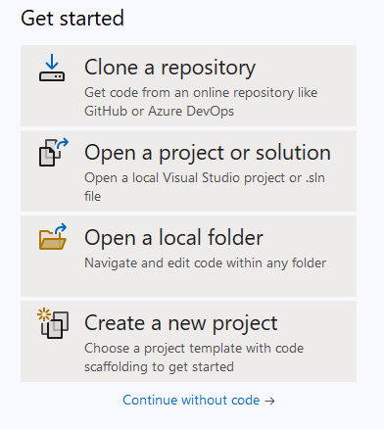

In the “Create a new project” dialog, use the search bar to search for “Empty Project”. Select “Empty Project” from the list and click Next.
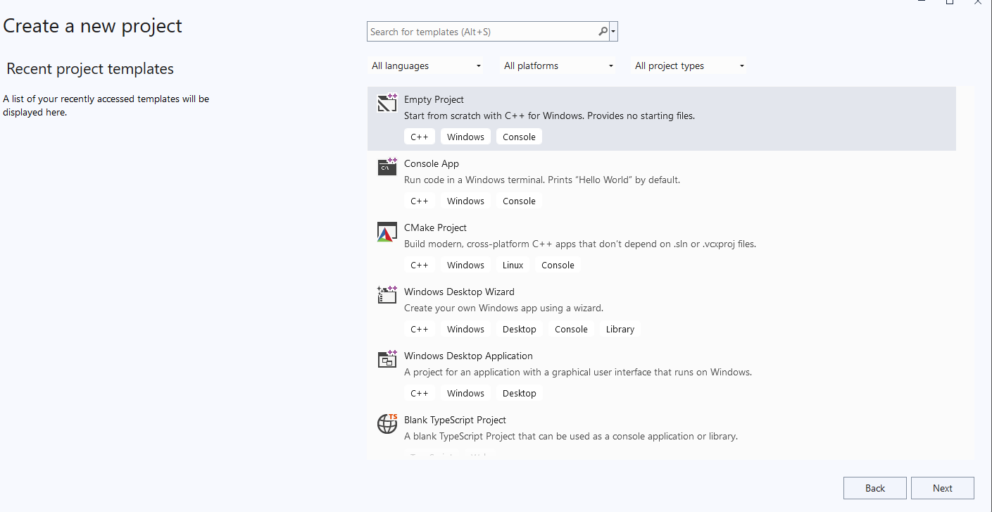

Step 3: Configure Your Project
Enter a name for your project (e.g., “MyCppProject”). Choose a folder where you want to save the project by clicking Browse (We may save it on the Desktop). Click Create to proceed.
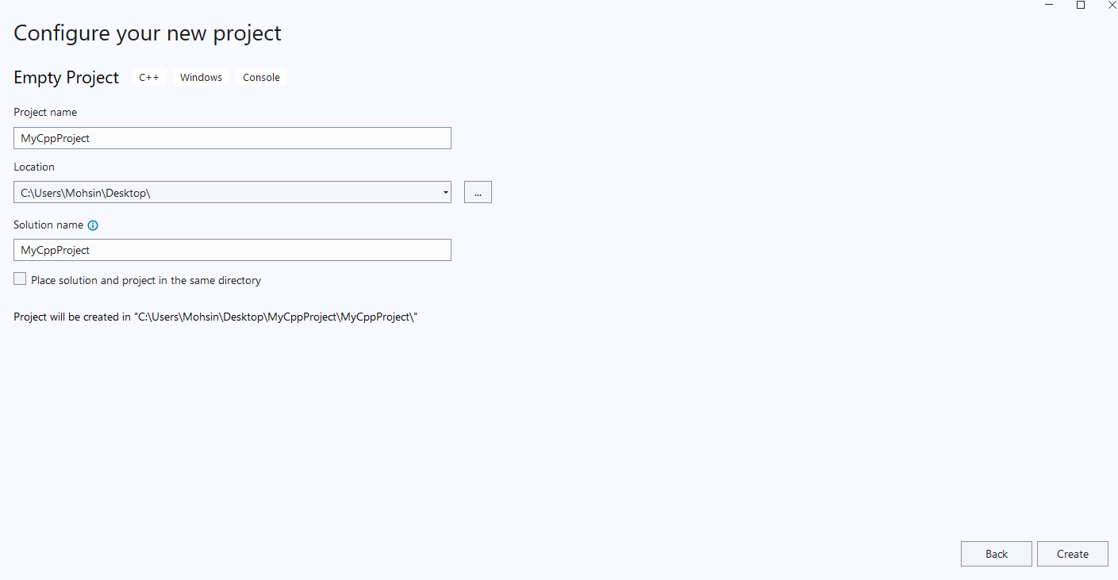

Step 4: Add a .cpp File to the Project
In Solution Explorer (which is usually on the right-hand side), right-click on the Source Files folder. From the context menu, select Add > New Item.

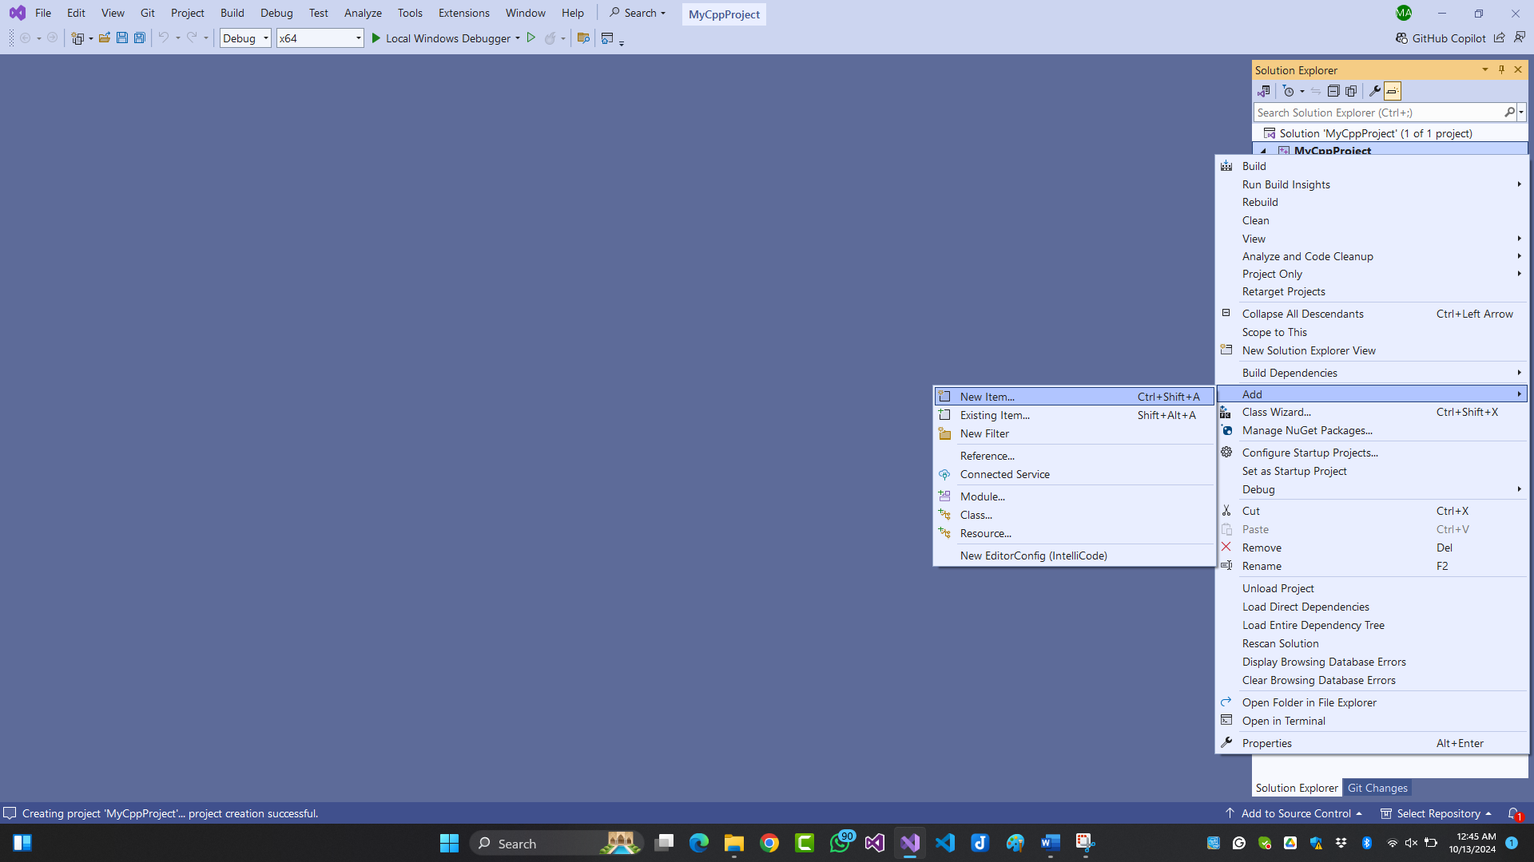

In the “Add New Item” dialog box, select C++ File (.cpp). Enter a name of your choice for your C++ source file (e.g., “myFirstProgram.cpp”). Click Add.

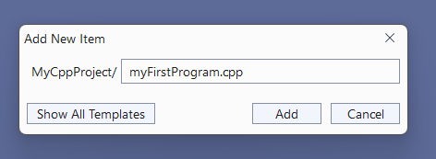

Step 5: Write Code in the .cpp File
Visual Studio will now open the myFirstProgram.cpp file in the editor. You can now write your C++ code. For example, you can add the following simple program:

#include <iostream>
using namespace std;

int main()
{
cout << "Hello, World!" << endl;
return 0;
}

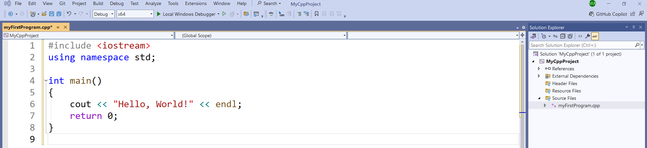

Step 6: Build and Run the Project
After writing the code, press Ctrl+F5.

Step 7: View Output
A console window should open, displaying the output of your program (e.g., Hello, World!).
